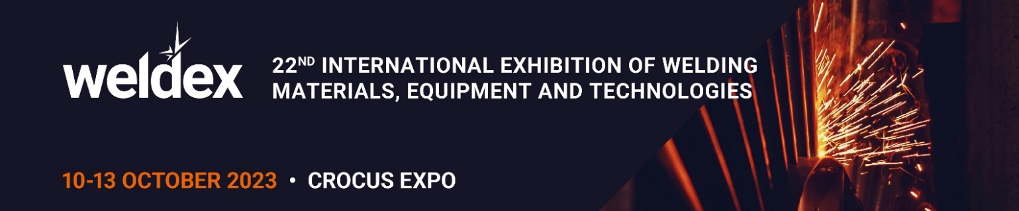

Dear ____

Our Company ___ invites you to visit our stand at Weldex –the largest in Russia international exhibition of welding materials, equipment and technologies from 10 to 13 October 2023 in Moscow, Crocus Expo, Pavilion 1, Hall 4.

The exhibition will feature a wide range of equipment and materials for welding, metal cutting, application of protective and hardening coatings, quality control of welded joints, edge treatment, as well as industrial robots, tools and appliances for welding, personal and collective protection equipment for welding.

Our company at the exhibition will present:

- Please list which products/new products/services will be presented at the stand.

Using our link with promo code ________, you can get a free e-ticket at www.weldex.ru. Without a promo code you will have to pay to visit the exhibition.

Get an e-ticket for free(put your individual link to get a ticket with your promo code https://weldex.ru/ru/visit/visitor-registration/?utm_source=exhibitor&utm_medium=referral&utm_campaign=eticket&promo=YOUR PROMOCODE (insert your promo code after promo= )

Note: Promo codes are only valid upon receipt of an e-ticket on the exhibition website and are valid until the end of Weldex 2023. A promo code can be used an unlimited number of times.

Regards,
_____________

